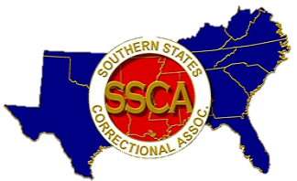

**Southern Concourse Advertisement Form**

The Southern Concourse is the official publication of the Southern States Correctional Association.

**Company Name:**

**Website:**

**Mailing Address:**

**Contact Person:**

**Email:**

Check one of the options below:

____ One (1) issue half page ad **$100** ____ Four (4) issues half page ad **$225**

____ One (1) issue full page ad **$150** ____ Four (4) issues full page ad **$400**

Please send:

Vector image ad to [SSCAjoin@aol.com](mailto:SSCAjoin@aol.com)

Check made payable to SSCA and then mail it to the following address:

SSCA – Southern States Correctional Association

Attn: Southern Concourse Advertising

PO Box 928

Crestwood, KY 40014

Thank you for supporting SSCA through the Southern Concourse!